Cultural Anthropology Unit

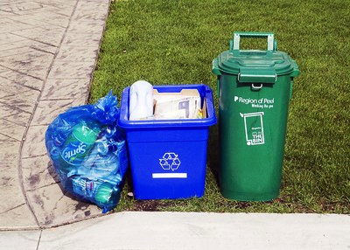
http://news.ca.msn.com/ontario/mississauga/holiday-alters-trash-collection

Owen Brake
Observing Rubbish
An archeology assignment

Rubbish!
What can you learn about a culture by looking in the trash?

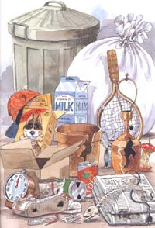
Garbage or goldmine?

Archaeologists study human culture by analyzing artifacts and sites that people leave behind. One of the best places to find artifacts is in the garbage. Archaeologists call such places middens. For this activity you are going to do a field study and seeing what you can find out about our culture by looking into your own garbage and what it is like to be an archaeologist.

Materials needed:
- Gloves (you should wear these while dealing with waste)
- Tarp (to sort out your waste on)
- Seven days worth of waste (include recycling, but not organic waste)

Steps:

- Collect your waste from home before it goes into the garbage for seven days.
- Collect from different places at least three areas of your home
- Do not include organic waste (things that rot)
- Sort out the garbage and itemize it.
- Use the contents inventory charts provided for itemizing+photos
- Analyze your findings.
- Use the questions provided to assist you
- Write a summary of your findings.
- This should be about a page in length

Assessment:
You will be assessed on your written work and your presentation. Please not that all your work must be typed. You must hand in:
- Marking scheme
- Contents inventory charts (from three places in your home)
- A Reflection based on your findings.

This assignment has been modified from: http://www.usouthal.edu/archaeology/education_clues-to-the-past.html

What is the Anthropology of Garbage?

Load up the pantry? Or, load up the landfill?
Posted by Christopher Witmore
Excerpt taken from: http://traumwerk.stanford.edu/archaeolog/2008/06/load_up_the_pantry_or_load_up.html

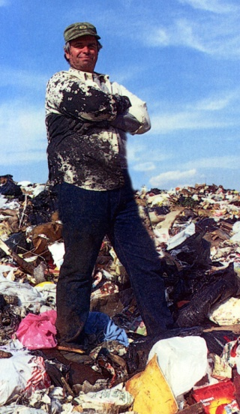
Archaeologist William Rathje has been called the Indiana Jones of solid waste

The lesson is one offered by archaeology, well to be more precise, garbology.
From 1973 to 2005 William Rathje ran the Garbage Project out of the University of Arizona where he was a Professor of archaeology. The Garbage Project took a very different approach to the study of consumption. Faithful to a maxim of our current era, ‘what we say we do rarely matches up to what we do,’ the project focused on discard patterns in garbage. You claim to drink only 4 beers a week? You laud your efforts at recycling? Well your trash says otherwise.

Rathje and team spent years sorting through household rubbish in Tucson. Beginning in 1987 the Garbage Project also began excavating landfills. From Mullins Landfill in Tucson, AZ to Fresh Kills in New York, NY, from the Durham Road Landfill in Freemont, CA to Brock West Landfill in Toronto, Canada; they would dig in over twenty landfills throughout the US and Canada.

So what does trash have to say about responses during periods of food scarcity?
In 1973 the United States went through a beef shortage. Over a fifteen-month period beginning in the spring of that year, the Garbage Project recorded information on the amount of beef purchased in comparison to the amount discarded by household in Tucson. They found that households tended to waste three times more beef during the shortage than they did otherwise. And this wasn’t limited to Arizona.

If only in a small way, the Garbage Project’s findings were further substantiated by Chicago landfill excavations. For example, in a layer dated by newspapers (May 5, 1973), Rathje and his team found discarded steak still in the packaging. This was precisely in the middle of the national beef shortage.

Contents Inventory
Location 1: Washroom Garbage Can

Item (Physical Appearance) | Inference (What is the item used for, Assumptions) | Element(s) of culture/Cultural universal(s)(Where does this fit in the culture)
Gift wrapping paper and balloons | The family has just had a birthday party | Rituals – birthdays are celebrated annually
  Cetirizine hydrochloride tablets | Someone has seasonal allergies in the house but no longer require them due to the remaining pills leftover. | Medicine – taken to relieve symptoms of allergies
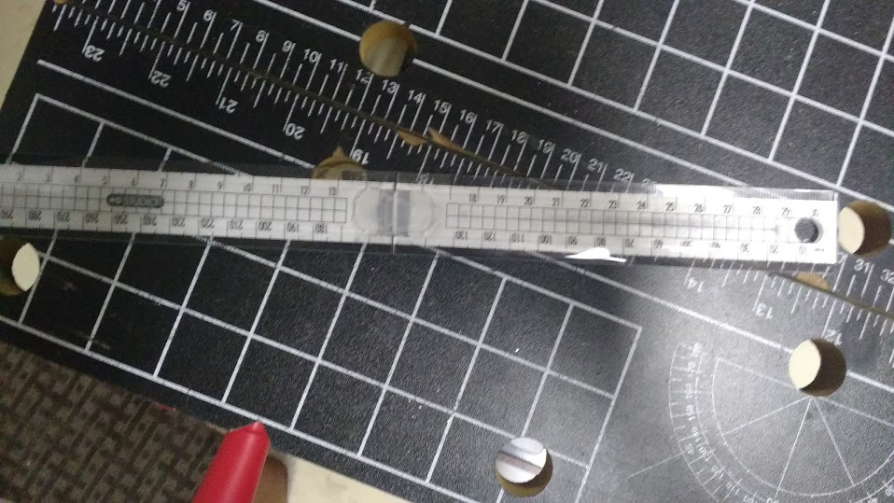  30cm ruler | The ruler is broken indicating it is cheap and most likely owned by a child. The ruler is in metric indicating that the family may live in or originate from a country that follows the metric system | Tool
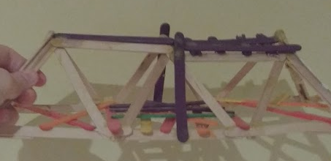  Multicolored popsicle stick bridge | A small child in the family had a school project. | Art  Rituals- Goto school 5 times a week
Fusidic Acid cream, half empty.   | Most likely someone in the house had an infection and had gotten it within the last two weeks since the cream is only prescribed in short term use. The infection has stopped due to it being thrown out, half full. This could mean that someone has gone into a forest for an extended period of time or been in an unsanitary location. | Medicine – taken to remove bacterial infections.
  Spectro skin cream, empty. | There is a teenager in the family with acne. | Appearance – applied to remove acne.  Social Rules - Society dictates that these natural occurrences are “dirty” and need to be treated.  Rituals – Skin cream is applied daily
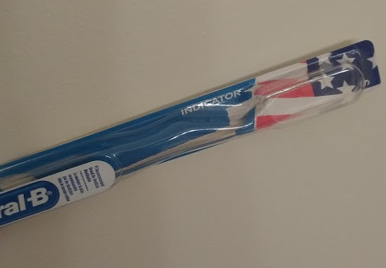  Oral-B empty toothbrush package with American flag. | There is an empty toothbrush package indicating that the resident got a new toothbrush. The resident may be from America and has strong nationalistic principles. | Rituals - Brushing your teeth. Often at least twice a day.  Social Rules – People are expected to brush their teeth 2-3 times a day  Tool
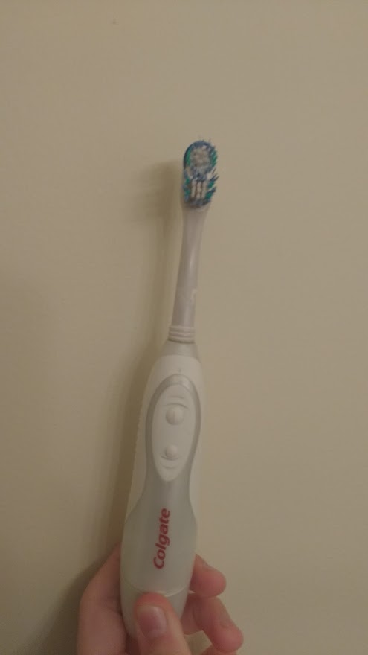  Electric toothbrush, working condition, lightly used. | There must be an elderly person in the house. An electric toothbrush is used for people who have difficulty using strength to brush their teeth. | Rituals – Brushing your teeth. Often at least twice a day.  Social Rules – People are expected to brush their teeth 2-3 times a day.  Tool
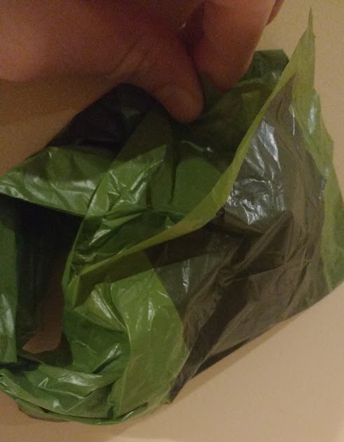  Damaged Dog Poo Bag. | There is a dog in the house. | Social Rules – Society says that people should pick up the poop of their pet after they are done.  Container – Holds the feces of a dog
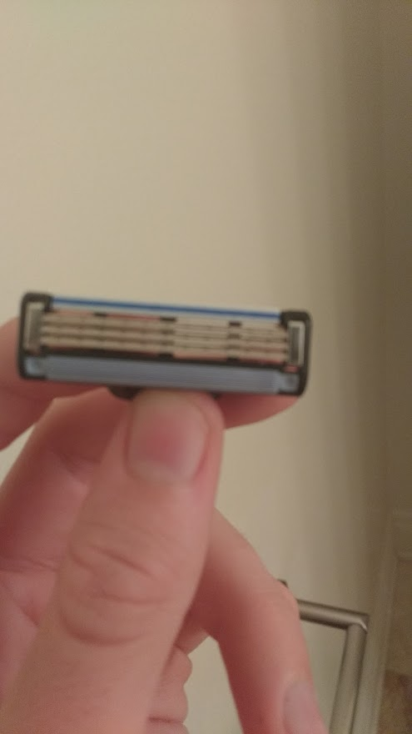  Razor Blade | One or more people in the house own a shaving razor. This would indicate that someone has hair on their body that they would like to remove. | Social Rules – people shave because society says that having too much hair on the face or body is unclean, this changes based on men and women.  Gender Roles – Though men do shave, women do so more than men because on men it is seen as masculine and strong whereas on facial hair on women is seen as dirty, disgusting and primitive  Rituals – Shaves often
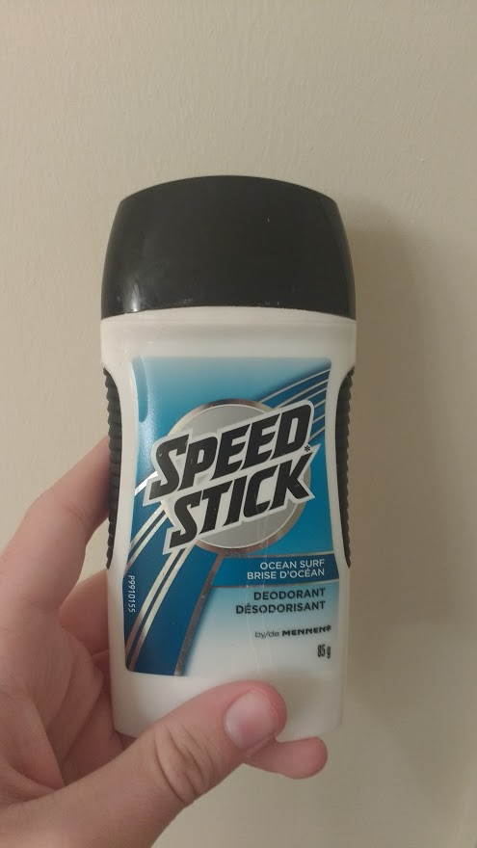  Deodorant | There is an adult male in the house that applies deodorant. | Social Rules – society tells us that we should not smell badly and that to remove the smell is to purchase deodorant  Gender Roles – This deodorant pack is marketed towards a male body due to the color scheme and the fact that there is a separate product in pink for women pushing the idea women are delicate and pink while men have darker more strong colors.  Rituals – Apply deodorant daily

Contents Inventory
Location 2: Kitchen Garbage Can

Item | Inference | Element(s) of culture/Cultural universal(s)
Empty bottle of Axe body spray | There must be a young male in the home | Gender to classify people – product is marketed to young males  Social rules – to smell good/use unnatural scents to be appealing
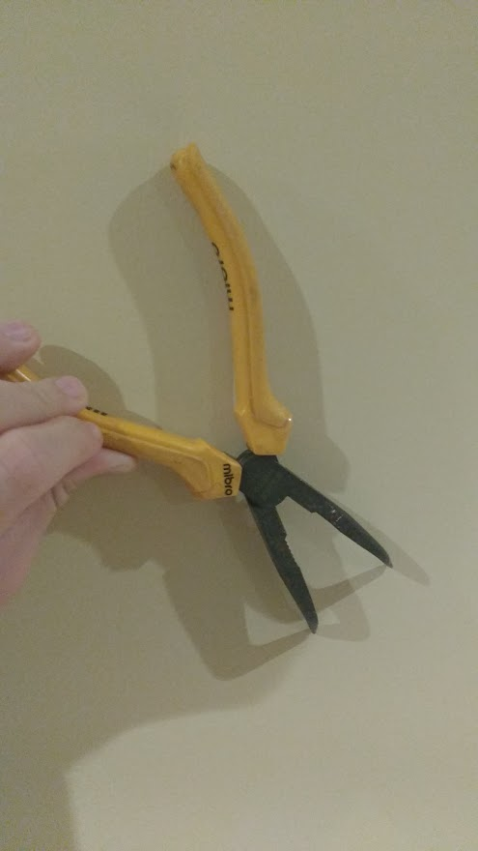  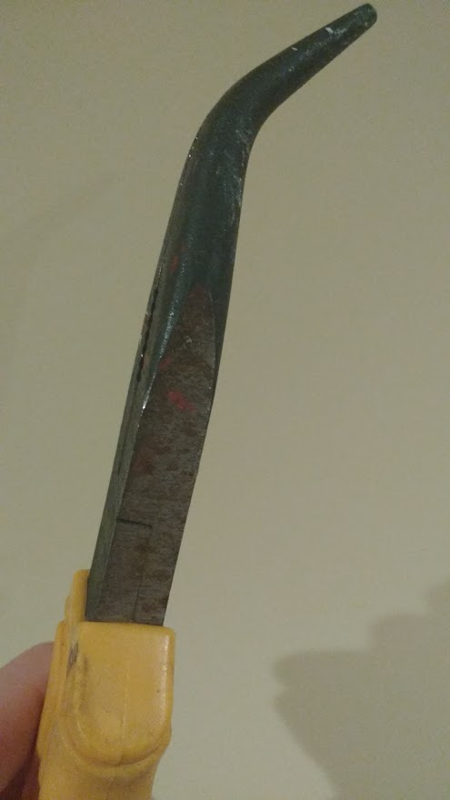  Rusted Pliers | The pliers were bought for a single purpose and then disposed of. These pliers are rarely used and not taken care of due to the rust, potentially left in a moist environment. | Tool
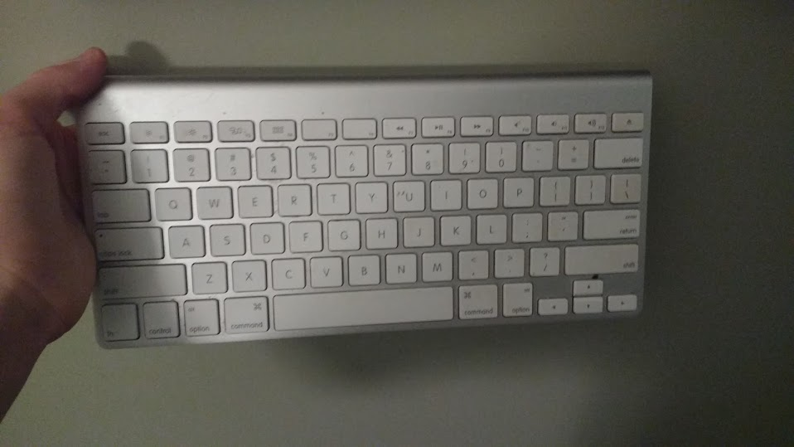  Apple Bluetooth Keyboard | There is a computer in the house which uses a wireless Bluetooth mac keyboard. | Tool
  Kraft Dinner container | The family enjoys convenience foods. Easy to make so therefore potentially a child could make it or a parent could make it quickly after work. Also very cheap reflecting how some parents have to feed their children cheap, processed food so that their children can eat. | Food
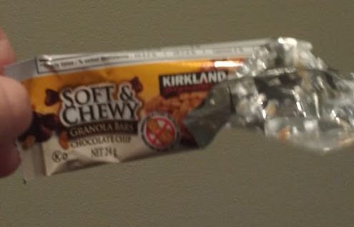  Granola bar wrapper | The family has children, who enjoy granola bars. Very cheap indicating that children are being forced to eat processed food rather than fresh food due to it being cheaper and more mass produced by companies. | Food
  Used $25 Steam gift card | The steam gift card is most likely a gift to one of the residents of the house. The steam gift card was used indicating that the recipient has bought something from the steam store. This would also guarantee that the recipient has a computer most likely a windows computer. | Trade
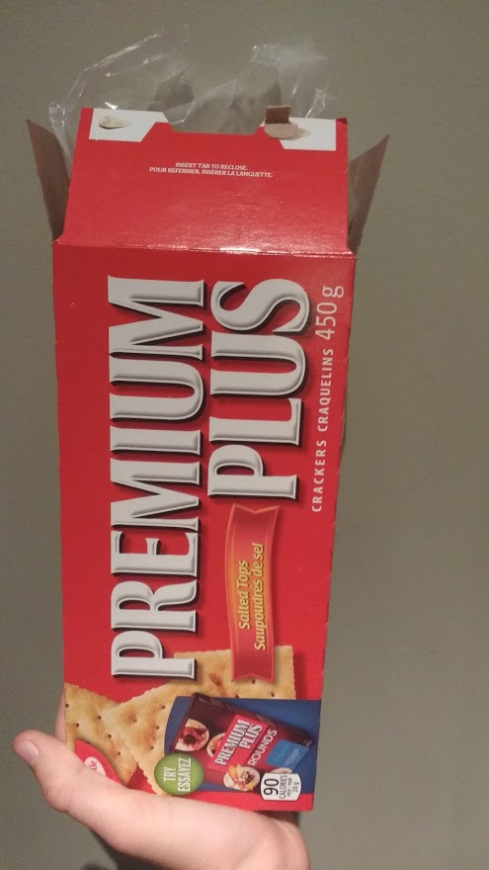  Package of Premium Plus Crackers | The family enjoys to eat soda crackers. The family is very frugal since these are very cheap for the large quantity of crackers. | Food
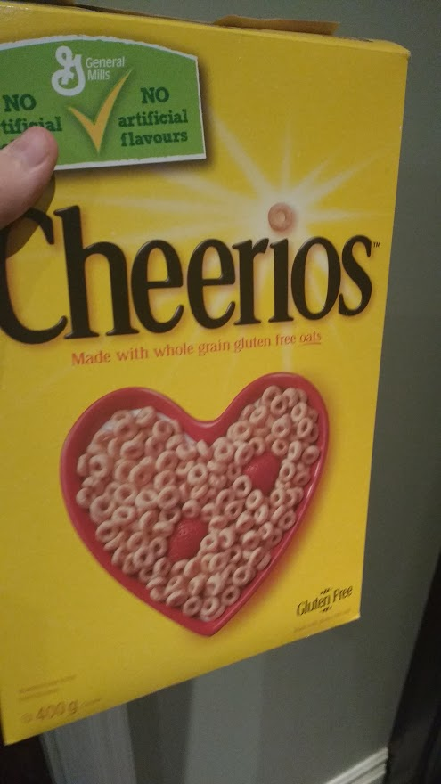  Pack of Cheerios Cereal | The residents usually eat cereal for breakfast. They are also fairly health conscious picking whole grain oats over the standard brand. One resident may have a gluten allergy due to the cheerios being gluten free. | Food
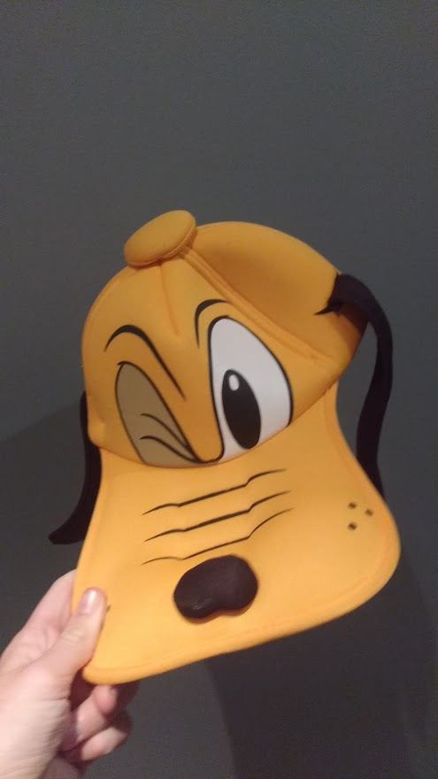  Goofy Disney Hat | There is probably a child who used to like goofy the Disney character however has outgrown these childish characters. The family may also be middle to upper class because they’re able to afford buying a short term, child’s hat. | Dress
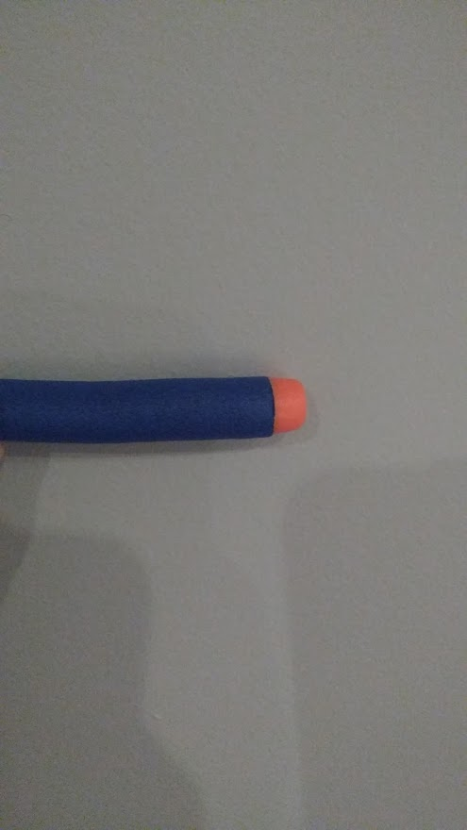  Broken Nerf Bullet | There is a child in the house who enjoys playing with nerf guns. | Gender Roles – Nerf guns are targeted towards male because guns are associated with masculinity.  Toy – The nerf gun is a toy
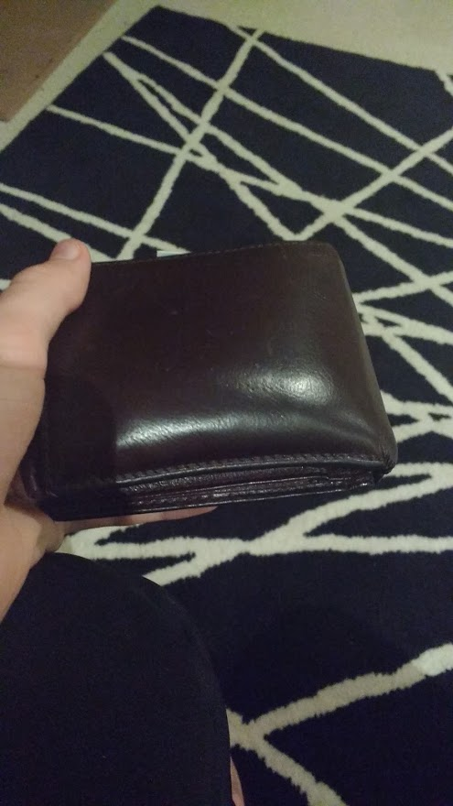  A Brown Wallet | Someone in the house is replacing a wallet most likely because this type of wallet is out of style a quite heavy. | Trade – A wallet holds currency which can be used to trade for goods and services  Container – Holds money, receipts, and cards.
Anthropology methods and skills assignment
Rubbish! What can you learn about a culture by looking in the trash?

Contents Inventory
Location 3: Garage Garbage Can

Item | Inference  Draw a cultural anthropological conclusion | Element(s) of culture/Cultural universal(s)
Boxes from pizza x 4 – in recycling | Family likes convenience foods and/or adults work long hours leaving little time for home-cooked meals. This may reflect modern gender roles in Canadian society as women often work long hours outside the home. | Food
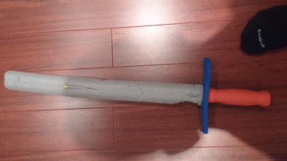Broken foam sword | The family has/had a male child and that child enjoys/enjoyed playing with foam swords. The child was playing and then it broke. | Gender Roles – The male is supposed to be masculine and be strong like fighting with swords  Toys – The child uses the toy to play
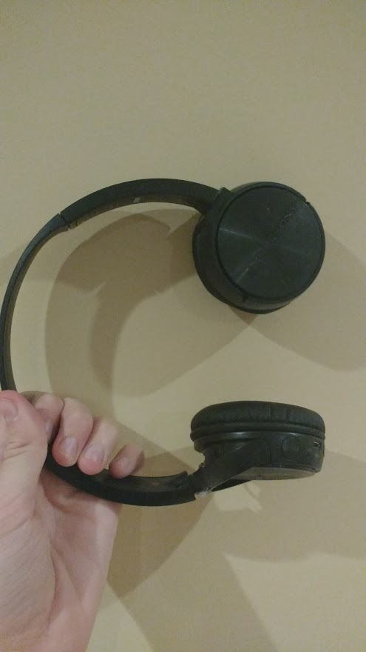Broken Headphones | One family member had headphones and they broke. Rather than repairing the headset it is being thrown out, though it is still working it does not look aesthetically pleasing. If the family member has disposed of the headphones over aesthetics than it most likely is going to be replaced. | Tool
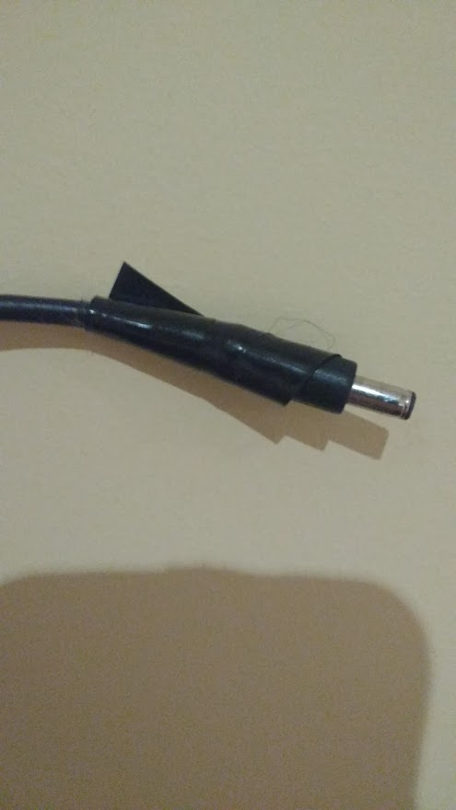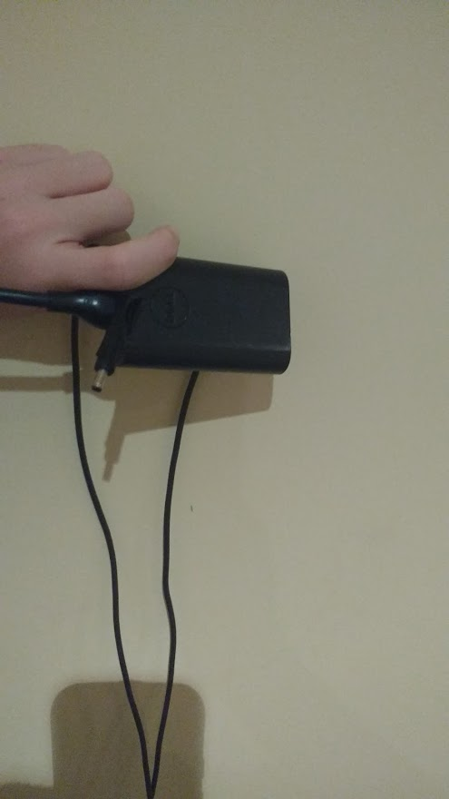Broken Laptop Adapter | A resident in the house has a laptop. The laptop charger has electrical tape indicating that it is taken care of poorly and most likely used by a child. It is being thrown out most likely because it is broken. | Tool
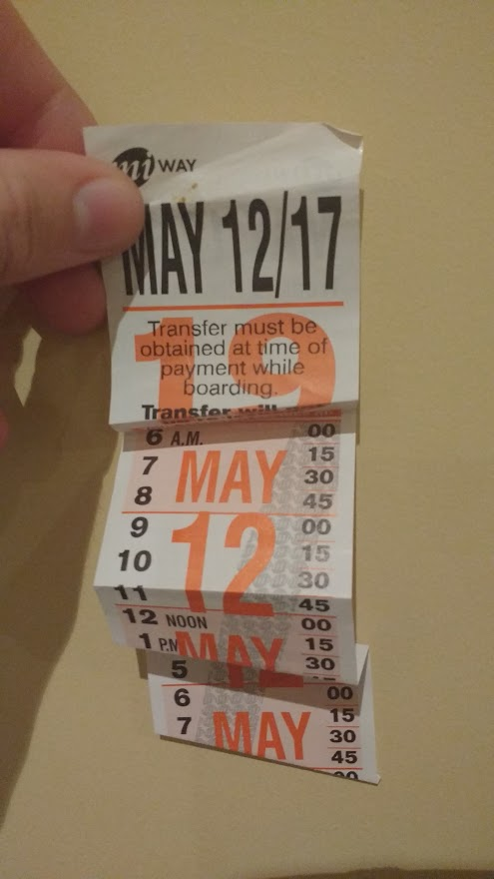MiWay Bus Transfer | A person in the house took the bus. Though it may appear that is their main form of transportation, the transfer is dated for quite a long time ago indicating that this was a one time trip. | Transportation
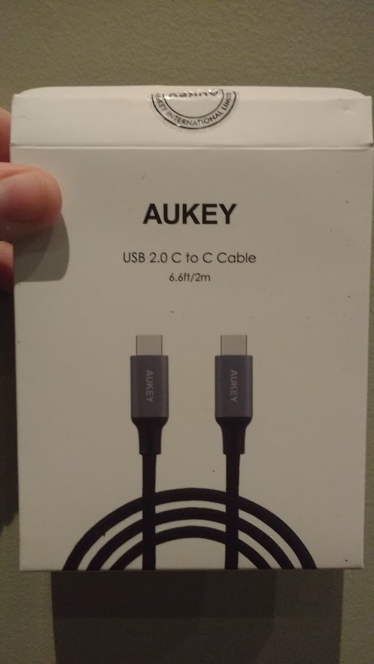Empty USB-C cable box. | A person owns a device which has an usb-c port most likely a laptop or an expensive phone. This could possibly indicate that a resident has bought a new device. If the resident has bought a new device this could mean that a previous device has been disposed of. | Tool
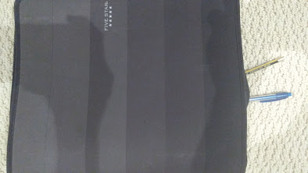School Binder | There is a person who is in school most likely middle school or high school. The binder is damaged indicating that they must have replaced it. | Container – Used to store notes and writing utensils  Rituals- Go to school 5 days a week
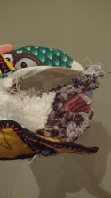  Ripped Dog Toy | There is a dog in the house. The dog is quite large with sharp teeth. | Toy
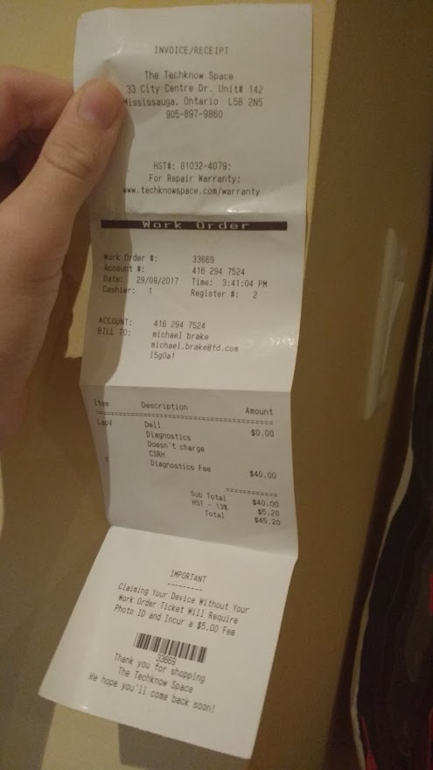Receipt for tech support | One of the residents has sent their Dell laptop to TechKnow Space. Most likely the laptop has been damaged, the laptop is probably made of a poor material causing it to be easily broken of the owner may be careless and reckless. | Trade – There was a 40 dollar fee for the tech support’s services
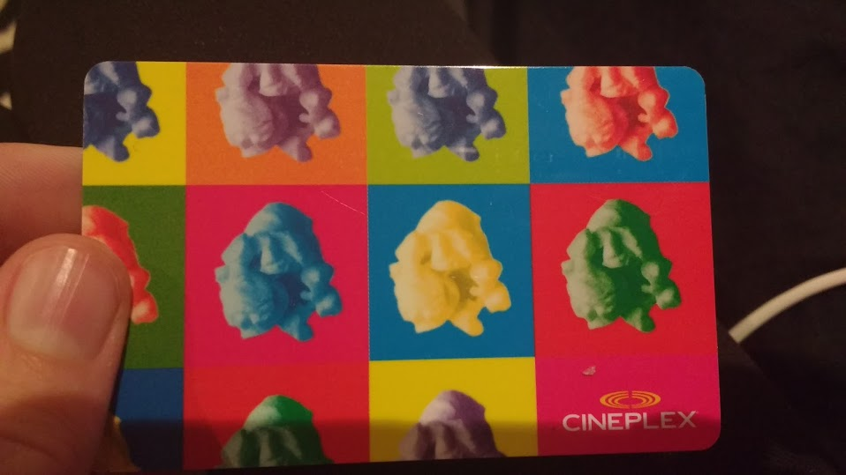A $25 used Cineplex Gift Card | Someone in the house has been to a Cineplex in the last week and used this card there. | Trade
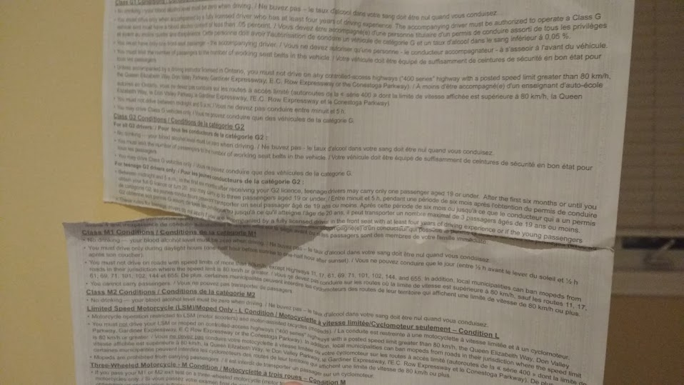Temporary G1 paper license | A resident probably a 16 year old has passed their G1 knowledge test and have received their permanent driver’s license card 4 weeks after they have passed the test so no longer require the temporary paper license. | Transportation

Cultural Anthropologist a 7 day Observation Assignment

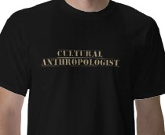
Don’t worry, you do not have to wear this shirt when conducting interviews/observation!

You need to reflect on two or three aspects of culture that are demonstrated within your family by studying your waste. The categories you may choose to reflect upon must be three of the following:

Family Life (structure and purpose, marriage, child rearing)
Knowledge and Beliefs (cultural values, religion)
Art (types of artistic expression, purpose and importance)
Recreation and Leisure (games, sports, preferred use of leisure time)
Communication (langages, non-verbal communication, )
Material Goods (clothing, housing type, food, transportation)
(adapted from p. 37 of Our Social World)
You are required to study the subculture of your family by conducting interviews with your parents or siblings or as a participant observer.

Steps

- Planning You must decide in advance what aspects you will be studying and what questions you will be asking your research subjects (informants). These questions must be approved in advance by your teacher and are due on: _______________.

- Implementation: An evening dinner is an ideal time to gather data, provided your research subjects are willing. Remember that when visiting a culture you must avoid ethnocentrism and maintain an attitude of respect and open mindedness.

- Analysis After your data has been collected, you will analyze your findings. Incorporate the answers to the following questions in your reflection.

  - you were to reach a conclusion about your study, what would it be?

Assessment:

You will be assessed on your written work and your presentation. You must hand in:
- Marking scheme
- Planning worksheet
- Observation worksheet
- Reflection
Anthropology methods and skills assignment Names:
Cultural anthropologist for a day . . .

Planning worksheet

You need to select three of the aspects below and develop questions to ask your subjects.

Family Life (structure and purpose, marriage, child rearing)
Knowledge and Beliefs (cultural values, religion)
Art (types of artistic expression, purpose and importance)
Recreation and Leisure (games, sports, preferred use of leisure time)
Communication (language, non-verbal communication, physical contact)
Material Goods (clothing, housing type, food, transportation)

Interviewer/Observer | Owen Brake
Date of interview/observation | September 27,2017
Subject(s) being interviewed | Lisa Brake
 | Michael Brake
Informant A: Lisa Brake

Aspect | Questions
Recreation and Leisure | Did someone in the family take their G1 knowledge test about one month ago?  Does someone in the family enjoy playing with nerf guns?
Material Goods | Does someone in the house own a laptop?  Did anyone in the family bring a laptop into TechKnow Space for repairs?  Does this family own a car? Is this their main form of transportation?  Does someone in the family have a gluten allergy? If so is it serious? If not than why are gluten free food products purchased?  Is most of the food in the family cooked fresh or processed? Why?
Family Life | Does your family own a pet? A dog? Is that pet large? Are they an important part of the family?

Informant B: Michael Brake

Aspect | Questions
Knowledge and Beliefs | Is your family religious? If so what religion? Is it important to family life?  If your family American? Are there strong nationalistic beliefs in the family?
Art | Does a small child in the household have art class in school? Did they build a bridge in that class?  Is art important to this family’s life?
Communication | Does the family in the household speak English? If not what language?  Is non-verbal communication important in your family?
Anthropology methods and skills assignment Names:
Cultural anthropologist for a day . . .

Location Observation worksheet

Questions or aspects being observed | Observations
Location 1  (Bathroom garbage can) | The bathroom garbage can is filled with stuff. There is a lot of trash filling up the bin. The bin is metal and has a somewhat conical shape. The bin is made up of mostly toiletry package and disposable containers. There are however some random items that seem out of place since this is in the bathroom though the bathroom has the only garbage can on the second floor of the building. Besides the fact that the garbage can is full the can and its surroundings are quite clean.
Location 2  (Kitchen Garbage Can) | The kitchen garbage is a plastic, pull out style garbage can which has a replaceable bag. This garbage can is in a very poor condition with many food wrappers, however there are some miscellaneous objects. The garbage bag has objects of food on it clearly because all food waste that cannot be put in the compost goes into this garbage bin. Though the garbage bag appears to be in a rough shape, the actual exterior is white and is in a perfect condition.
Location 3  (Garage Garbage Can) | The garage garbage can is the collection station for all the garbage bags in the building, due to it being where all the garbage is eventually taken the can is quite large. Though it is where all the garbage bags go there are still some objects that are thrown in this area without being put into garbage cans. It appears to be made up of many miscellaneous items but mostly items that would be either too big or too difficult to put into the smaller garbage cans. The garbage can is in a good state due to the majority of the garbage being put into bags however there is some dirt indicating that the garbage can had been open for a period of time and it has not been cleaned for an extended period of time.

Reflections Questions

Please answer these questions in a one page detailed response.

- Which of the elements of culture/cultural universals you observed were the most noticeable and why?

The most common elements of culture were food and tool. This is because humans require so much food since it is a fundamental thing we require to survive. Now that humans in capitalist, imperialist nations have a near infinite food supply they can consume as much as they want which has been uncommon for the last two hundred millennia. We use tools so much because they are what separates us from other hominids, the human race uses tools so much because that was our specialty, and the Neanderthals had tools however they lacked the ability to improve them. Humans were able to perfect tools and create new ones which allowed us to become the superior bipedal creature since we were the ones who could best adapt to our environment according to Charles Darwin’s Origin of the Species. Though food and tools are the most common the most noticeable one was social rules. Many objects including ones that appear to be quite simple exist because society deems it is necessary and enforces it as a social role. It was shocking that ordinary tools such as a toothbrush existed because society believes that people’s teeth must be clean not because these are universal objects. Society has such a role in people’s lives that we cannot begin to identify what because nearly everything that we do is because society deems it necessary, acceptable or taboo. Nearly every person can be described as a conformist whether that person believes it or not because society and culture is so ingrained in us as people that we cannot determine what society has told us to do rather than what we choose to do. Do people choose to go to sleep when the sky becomes dark or is that just the socially acceptable time to sleep, do people choose to eat food at certain periods of time or is that just the socially acceptable time to eat? Another very noticeable cultural universal was rituals. So much of our day in this capitalist society is based around a routine and because of this rituals are so common. Most people spend their entire lives repeating the same rituals because it is necessary. So much of our lives are now based around these rituals because if we were to abandon these rituals than we would be socially ostracized and seen as lazy. If someone were to not shave before going to work than they may not still have a job, if someone were to not show up to work they would lose their job, if someone were to wake up at a different time than normal than they may lose their job. Every person’s livelihood is based around that they follow the rituals society tells them to follow if someone were not to follow these rituals than they would be punished. The real question however is whether these are truly personal rituals, does someone choose their rituals from my study it appears that people do not actually choose their rituals these rituals are given to them and learned. People do not really choose their rituals, if they truly had a choice they would not face harsh consequences if they break such routine, they would not be given a sentence to death by removing their livelihood.

- Explain how the elements of culture/cultural universals you observed are related to one another. For example, what is the connection between food and gender roles? What about food and religious beliefs etc.?

The two elements with the biggest connection would be gender roles and social rules. The way society expects people to look, act or think also tends to have a parallel idea for another gender. For example society expects most people to apply deodorant to prevent people from emitting odors. Though deodorant is a product that emits no odor itself, these corporations market two different types one for men and one for women. These companies do this because they understand the insecurity of people they understand that if they market a manly product towards men than these men will want to purchase the product to fit in, the same goes for women. These corporations reinforce these stereotypes so they can continue to make sales for their company, even though there is no functional difference someone would not want to buy the product of another gender because it would be seen as either too feminine or too masculine by society. Another example is that women and men are both expected to shave their facial hair. Though they are both expected to do this yet again there are two different products that reinforce the stereotypes of the gender to make customers feel like they fit in with that stereotype by purchasing the product. For shaving it is also expected that women shave their legs which is seen in western culture to be attractive however if a male shaves his legs than it is seen as too feminine and weak. It is quite shocking that for nearly everything that society expects people to do there is a role that the other gender must fulfill. It is subtle however people just accept that it is normal that every single task that a person is expected to do there is a different role that the other gender must follow, these sexist stereotypes are damaging however we accept them because it is what society tells us to do. Another relationship was between rituals and social rules. Rituals appear to be nearly the same to social rules in a modern culture. One major thing I discovered when doing this study was that people do not actually determine their rituals, it appears as though society dictates people’s routine and if it is not followed strictly than one is punished. It is essentially a social rule to follow the specified rituals. Another important relationship between social rules and rituals is that they are intertwined. Most rituals are there because they attempt to enforce a social rule. For example people brush their teeth because it is a social rule to have clean teeth, people apply deodorant because it is a social rule to not have an odor. Our rituals are there to complete the social rule that is expected of us.

- How did you avoid ethnocentrism while you were completing your study?

Ethnocentrism is a very difficult problem for anthropologists and is important for this task. Analyzing a subject in an objective way could be considered impossible since people hold inherent biases that even they cannot identify themselves. In this project students had to analyze their own culture and determine how each item fits into this culture. This is a very difficult task because those who live in a culture just believe that a certain thing or task is normal and universal because that is all we have known. Specifically when identifying the cultural universals, realizing how objects fit into social and gender roles was very tough because it is just an accepted thing to do, society does not tell you to do something people believe it is something they do. For example being able to identify that the type of razor blade someone chose was due to gender and social roles took some time because all I had ever known was that this is what these people did not that it was a role imposed on people by society. One way that I used to avoid ethnocentrism was to analyze every object as if I was from another, by analyzing something from an outside perspective it gives a new look onto how each thing fits into our culture. Analyzing all these objects from this outside perspective took a lot of time and thinking because removing these biases we have is impossible and minimizing them is extremely difficult. Another way I avoided ethnocentrism was getting another person’s perspective, by asking other people specifically people from outside of this Canadian culture I was able to obtain information I could not receive from my biased view point. I asked people who were from countries such as India and China and they all had a different view of how these things fit into our culture, they all had a different way of how their culture ran in their own country of origin. However there was one big issue, with this growing globalization cultures are becoming more uniform which was causing some issues. People from more modern nations all had very similar viewpoints because multinational corporations had spread these ideas and stereotypes to their country enforcing these beliefs onto the people, so to get a unique perspective it was necessary to communicate with people with cultures from less developed countries like those of rural India, rural China and many more rural countries in Africa.

- How can you better understand your culture as a result of this assignment?

This project completely changed how I view my culture and how I view the culture of others. One of the things I did when attempting to avoid ethnocentrism was by talking with people from other cultures of how they see this object and how they think it fits into western culture. Through these conversations I was able to see how people from outside of western culture view this culture and get a less biased point of view by comparing everyone’s comments. I was now able to see people’s criticisms of our culture. I had not realized how sexualized women were and how much gender roles played an impact in our culture, though I had heard about the issue knowing the extent and how everyday objects reinforced societies stereotypes was truly shocking. Another thing was how much society pushes its ideals onto individuals, I did not realize how much I do because society expects me to do it, everything I did at home was because it was a social norm and I was afraid of being ostracized for not doing so. I apply deodorant not due to my perceived smell of myself but because society dictates that every person must do so. I apply chemicals to my face to remove acne not because I want to but because society tells me that there is an ideal body and people must aspire to reach that. I shave not because I do not desire facial hair however society tells us that having too much facial hair is dirty and wrong so people must shave. All of these things I was doing I thought I was doing because it was a universal human thing not realizing that it is western culture to have all of these aspects. The Native American people did not wear deodorant it was not a part of their culture but in modern western culture it is. I realized through this project that much of what people do is not because it is a universal concept and that many things are created by society and imposed on people.

5. Are we living in a society of consumerism, recycling, over production, etc.

Many of the products were thrown out though they could have been reused, we live in a society of capitalist consumerism where every product we buy is geared so as to make the most amount of profit for the producer. The current economic system is setup so the bourgeois have an incentive to create products which are non-reusable. The bourgeois wish to create products that have to be bought and replenished constantly, they do not aim to create a long lasting, permanent product they desire to create products that are cheap to make and will have to be bought again in a short period of time. In this corporatist economy, if a company has consistent sales, than the company is considered to be worthless, in this system companies must demonstrate growth or they are considered to be worthless. This constant need for growth leads to this idea that a business should create cheap products that will need to be replaced because if the consumer keeps coming back that creates more sales for the company. One method companies use to keep customers purchasing new products is through planned obsolescence. Especially with electronic devices, companies will use cheap components which wear over time and will break, once that component breaks most likely the product fails to function at all and the consumer must buy a new product. This cyclical nature of buying a product, the product breaks and then you have to buy another one is un-sustainable, the planet cannot provide the resources for these constant creation of new devices and the idea that these products need to be replaced. The capitalist system not only is bad for the environment but this consumerism affects those in the third world. Third world countries are in their state due to the exploitation of capitalist, imperialist countries now these countries are still suffering from the effects caused by the imperialism that happened in their country. Since these countries are still recovering, first world nations are taking advantage of them by employing people who will work for wages that are under the poverty line to work in dangerous conditions to create these products because multinational companies demand that every person has to replace their own product for a new, “better” one. These people have no other option because these companies know that they can pay these terrible wages since there are so many people who do not have a job in these third world countries and these people are so desperate for money.
Marking Scheme
Application

Criteria | Level 4 | Level 3 | Level 2 | Level 1 | No level assigned
Did you complete the research notes (charts) thoroughly and accurately  /10 | Research notes are 100% complete and with very relevant information included | Research notes are 100% complete with relevant information included | Research notes are mostly complete with some relevant information included | Research notes are somewhat complete with some relevant information included | What notes?
Does your reflection show insight into the culture being studied? Does it reflect an in-depth understanding of cultural anthropology?  /20 | Reflection shows substantial insight and demonstrates a sophisticated understanding of cultural anthropological concepts. | Reflection shows insight and demonstrates a solid understanding of cultural anthropological concepts. | Reflection is somewhat insightful and demonstrates an understanding of cultural anthropology | Summary shows little insight and does not demonstrate an understanding of cultural anthropology | What’s insight again?
Have you proofread your work for grammatical and spelling?  /5 | Work has been proofread well | Work has been proofread but a few easy errors were missed | A good attempt at proofreading has been made | A weak attempt at proofreading has been made | Work does not appear to have been proofread at all
is your photo-presentation thorough and accurate?  Is your presentation engaging?  /10 | Photo Presentation is very thorough and accurate.  Photo-  Presentation engages the audience. | Photo-Presentation is fairly thorough and accurate.  Photo  Presentation is engaging for the most part. | Parts of the photo presentation is thorough and or accurate.  Presentation-photos- are not overly engaging. More preparation needed. | Photo-Presentation is not overly thorough or accurate.  Presentation photos unsuccessfully attempted to engage audience. | Photo-Presentation is superficial and or inaccurate.  Photo Presentation did not attempt to portray any focused research.
TOTAL:  /45 | Comments:

